Spinning Racer
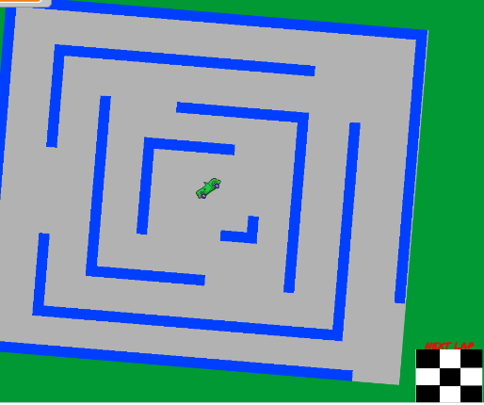
- Go to rmscoding.weebly.com. Click “Project Images” tab.
- Click “SPINNING RACER – Maze” Save picture to desktop.
- Click “SPINNING RACER – Next Lap” Save picture to desktop.
- Sprite 1: Upload “Maze” to sprite list.
- Sprite 2: Upload “Next Lap” to sprite list.
- Sprite 3: Add a race car sprite from the library.
- Your backdrop can be any color.
- Add the following code:
Race Car | Maze | Next Lap Sprite
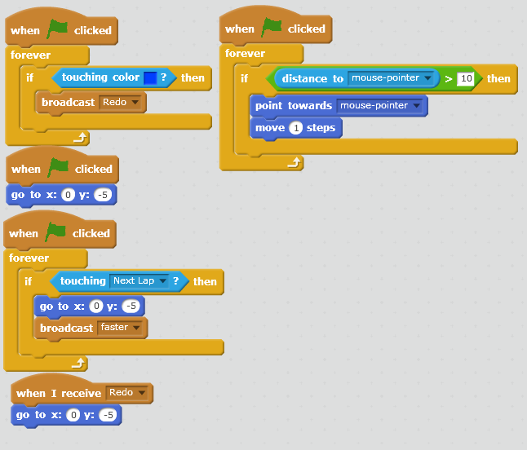 | The variable can be for all sprites.  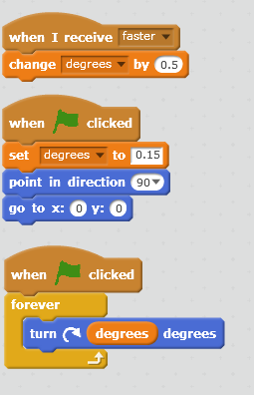 | 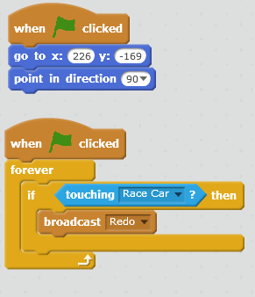

Add-Ons/Extensions:
-Create a coin system that your car has to get as it goes through the maze.
-When the car gets to the “next lap,” add an enemy sprite onto the maze so that the car has a harder time moving through it.
-Create different levels with different mazes to get through.
-Make it a two player game by adding another car that has to get through the maze.

