3D Simulation Racing Game
- Backdrop: Draw two colors to represent a sky and grass:
This game has SEVEN sprites that we will need to add:
- Sprite 1: Add ball sprite from library.
- Sprite 2: Add helicopter sprite from library.
- Sprite 3: Add tree sprite from library. (name this obstacle 1)
- Sprite 4: Add tree sprite from library. (name this obstacle 2)
- Sprite 5: Make new sprite that says GAME OVER.
Go to rmscoding.weebly.com and download: Player Car 1, Player Car 2, road 1 and road 2 .
- Sprite 6: Upload Player Car 1 as a sprite. In costumes, click folder and upload Player Car 2.
- Sprite 7: Upload road 1 as a sprite. In costumes, click folder and upload road 2.
Add the following code:
Ball Sprite | Tree (obstacle 1) | Tree (obstacle 2)
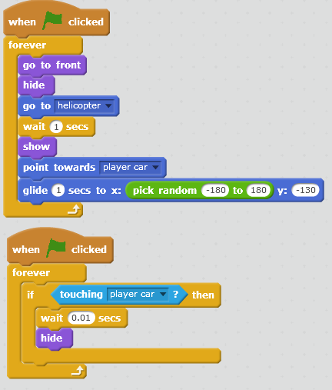 | 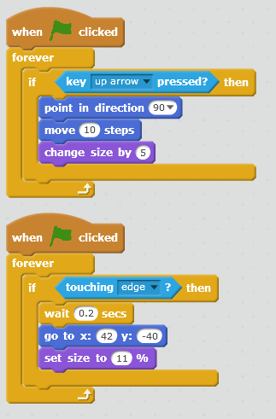 | 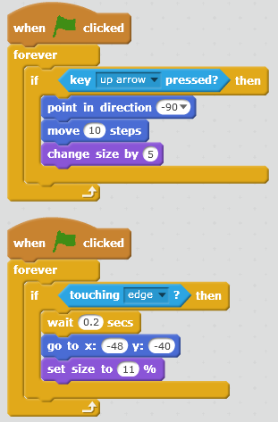
Game Over | Road | Helicopter
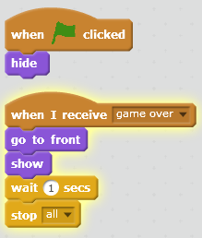 | 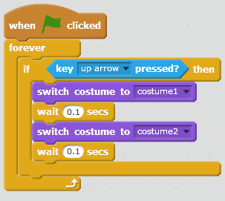 | 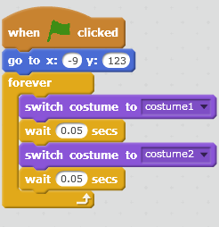
Race Car
