Flappy Bird Game
- Backdrop: Add a backdrop that you like.
- Parrot Sprite: Add the Parrot sprite from the library. 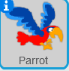
- Pipes Sprite: Draw a new sprite to represent the pipes. It should look like the picture shown to the right. Name the sprite Pipes.
- Coin Sprite: Draw another new sprite that looks like a coin. In this sprite, duplicate the costume (under the costumes tab) so that you have four costumes for the coin. Then, make the third and fourth picture of the coin narrower. An example is shown to the right:

- Add the following code:
(The variable can be for all sprites)
Parrot Sprite: | Pipes Sprite: | Coin Sprite
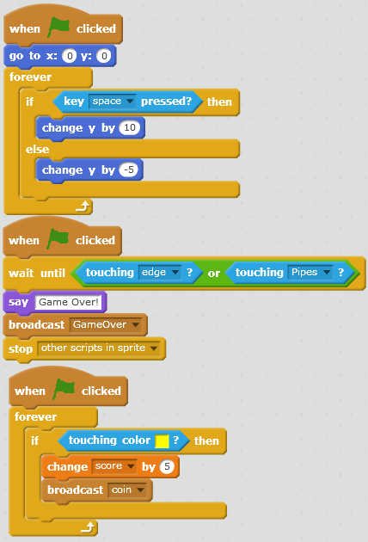 | 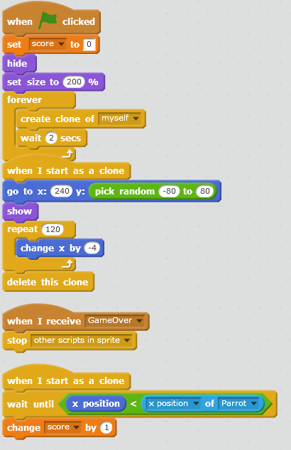 | 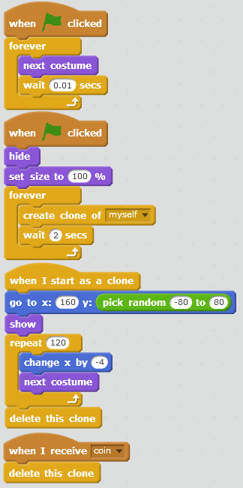

- Add-Ons/Extensions
  - Add enemy sprites that fly around the screen so that the bird has to avoid them while still making it through the pipes.
  - Play around with the speed at which the pipes are moving as well as the height at which the bird flies up and down.

