Catch the Dots Game
- Visit rmscodingweebly.com and click the Catch the Dots Starter Game
- Add the following code to each sprite:
Controller Sprite | Red Dot Sprite, Blue Dot Sprite, AND Yellow Dot Sprite  (Duplicate the code into each one)
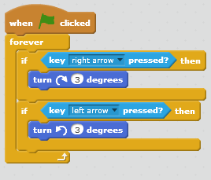 | 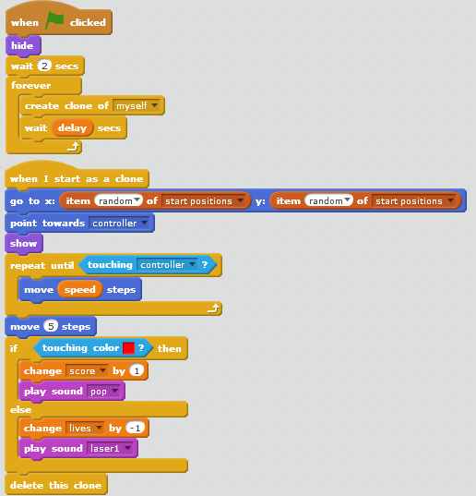  Make this 2 on the red sprite, 4 on the blue sprite, and 6 on the yellow sprite  Make this red on the red sprite, blue on the blue sprite, and yellow on the yellow sprite
Backdrop
